Thought Process + project evidence

Project Purpose & Scoping
Highlighted the instruction not to "over-engineer" and the permission to "adjust the brief as fit.”
- Decided to focus on a finished, well-scoped MVP rather than a half-finished, more complex workflow.
- Noted the 4-hour time constraint, so opted to be AI-assisted. Happy to talk through its usage during review.
- Brief is open-ended – “understand the current distribution and characteristics of EV charging points in Central London” - if in the workplace, I would clarify why.
Research & Data Selection
Heavily commercial environment with no single source of truth.
- Research shows providers must expose endpoints through OCPI, but connecting to 10+ individual provider APIs and aggregating them in BigQuery would take too long for this assignment.
- Middle ground… Open Charge Map:
  - Why? Open source, no licensing issues, contains the necessary geospatial/technical data to meet the brief, seemed easy to connect to, sufficient for MVP.
  - Limitations: Being crowdsourced, data quality can vary (duplicates or user-entry errors). Not “live”. Stale data?

Infrastructure Setup
Set up a new Google Cloud Project.
- Created a specific Service Account for the pipeline and assigned the correct IAM roles.
- Generated the JSON key file for local authentication.

Local Development & Testing
Registered an app to get an API key for Open Charge Map and tested the fetch logic locally using Python (requests/pandas).
- Inspected the raw JSON response to select appropriate data fields
  - Opted for ETL vs ELT here to save time in dev. In the professional world, I would usually opt to load the entire dataset to future proof against schema changes
- Ran a quick data quality check (see nimbus_assignment.ipynb):
  - Found postcodes that didn't follow the standard Outward Code + Space + Inward Code" format. No action taken despite being a potential issue for London postcode filtering and plotting.
  - Min/Max of last_verified date shows this data is not accurate. No action taken.
  - Lots of statuses unknown. No action taken.
  - Chargers with max power = 0. No action taken.
Deployment
When happy with the local development script, moved local execution in a Notebook environment to a Google Cloud Function.
- Moved away from the local credentials.json logic and switched to using the Cloud Function's built-in Service Account identity
- Made the function endpoint unauthenticated for this demo, here - https://nimbus-ingest-207053644354.europe-west2.run.app
- Scheduled the job using Cloud Scheduler to run weekly.
- See screenshots below for Cloud Function and Scheduling setup.
- See main.py and requirements.py for Python code in Github repo.

Analysis
- Made BigQuery Views for insights and analysis:
  - Aggregated data by provider and provided info on:
    - Classification of charger speeds into low, medium, fast.
    - Reliability metric (operational points/total)
  - Another View to be used in looker, omitting aggregation by operator
    - Concatenated lat lon for plotting individual charge points
    - Used low, medium and fast classification for plotting

Dashboard
- Pulled the data into Looker studio. Why? Google product, and so easily integrated with Big Query.
- https://lookerstudio.google.com/reporting/e9e3ca50-5934-4533-ad1c-d1922c08c101/page/wGegF
- Simple dashboard showing distribution of charger points, coloured by operator or speed, and with filters for key data dimensions. Page 2 shows the BigQuery View visually.

Key insights
- I took a strategic focus on insights…
- Nimbus can enhance its current property mapping portfolio with EV mappings to:
  - Sell a product specifically for EV developers, enabling them to find prime opportunities
  - Enhance property valuation for owners and developers
- Production challenge + real value:
  - To get real-time reliability for Nimbus clients, we'd likely need to ingest from multiple fragmented sources, direct OCPI connections. The engineering challenge then shifts to normalising 20+ different data schemas into the BigQuery model I built. That normalisation layer is where the real IP value of this project would sit.

Appendix

Cloud Function. See main.py and requirements.py for Python code:
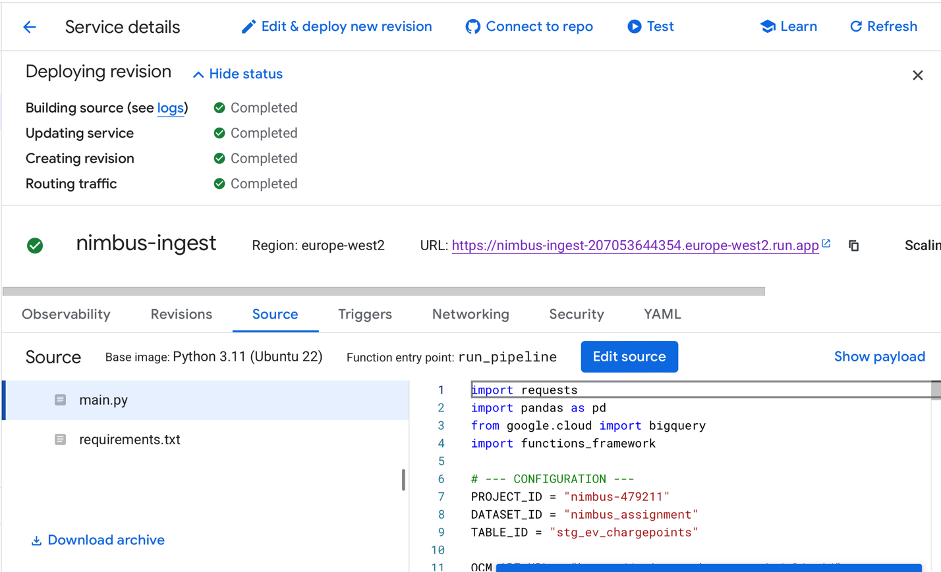

Cloud schedule setup:
